Redirection of Pipes

1. Create a file name error_log in your current directory. Suppose you do not have any file named aa11 in your current directory.

How can you redirect the error message to the file error_log when we apply the command "wc -l aa11" ?

How can you ensure that all the error log are appended to the error_log file?

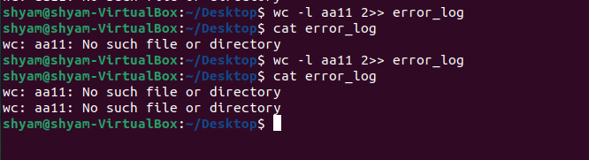

2. Create files named test1, test2, testa, testb

How can you count the number of files starting with test and then having only one digit in their name using only a single line command ?

